Patterns

- Ascending broadening price pattern.
- Insurance day bar.
- Inside day bar.
- once i have that information then i would put a sell stop right under the low of that day.
so notice again that i'm trading on a daily chart.
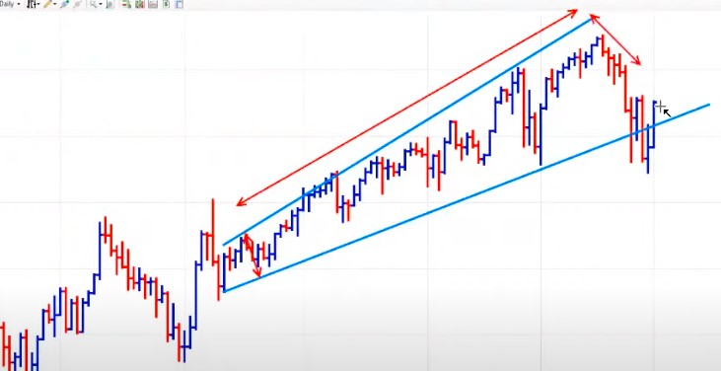
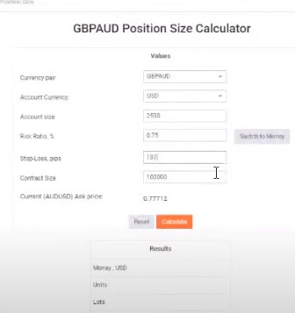

www.myfxbook.com

